Thread List / Text Feed Page:
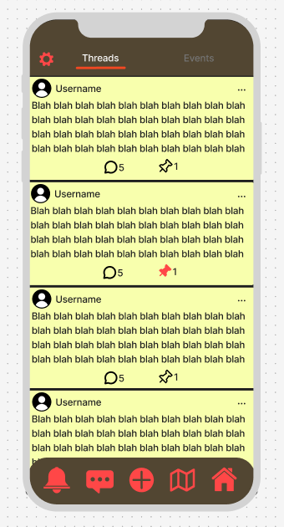

Thread Detail Page:
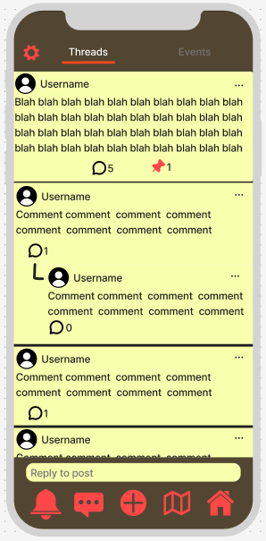

Color Palette:
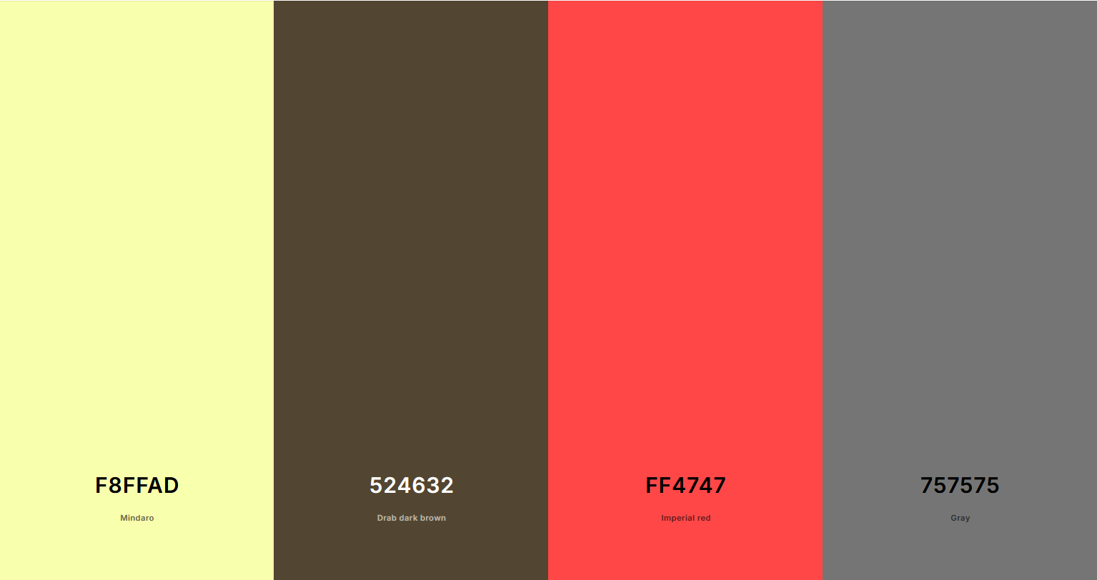
The colors I chose are meant to follow a bulletin board aesthetic; yellow for post-it notes, brown for the cork board, gray for the aluminum frame, and red for the thumb tacks or pins on the board itself. Yellow will make up most of the background color, followed by the secondary color brown. General icons and text will be in black/dark gray, and red will be the color of icons (icons can also be grayed out/just outlines, and the icon selected will be red).

I believe that this palette will have high contrast with one another while also being aesthetically consistent and pleasing to look at.

Figma link:
https://www.figma.com/board/mukZfT2nAbGDWuLrQrQbhJ/Mobile-Wireframe-Sketchpad--Community-?node-id=0-1&t=M3weII6VejoZ4leb-1

